**Question-Answer Platform API Documentation**

**1) DATABASE SETUP:** This platform has database with these tables listed Below

i) Question

ii) Answer

iii) Topic

iv) Tags

v) Company

vi) Subtopics

vii) Answer_comments

viii) Question_likes

ix) Answer_likes

x) User

**Relation b/w Database Table**

i) Question and Company - Many To Many

ii) Question and Tag - Many To Many

iii) Question and Subtopics - Many To Many

iv) Question and Answer - One To Many.

v) User and Question - One To Many

vi) User and Answer - One To Many

vii) Question and Question_likes - One To Many

viii) Answer and Answer_likes - One To Many

ix) Answer and Answer_comment - One To Many

x) Topic and Subtopics - One To Many

**Note: I am Also including the SQL Query File for the database.**

**2) URL FOR VARIOUS (Base URL- http://3.136.86.246:8000/)**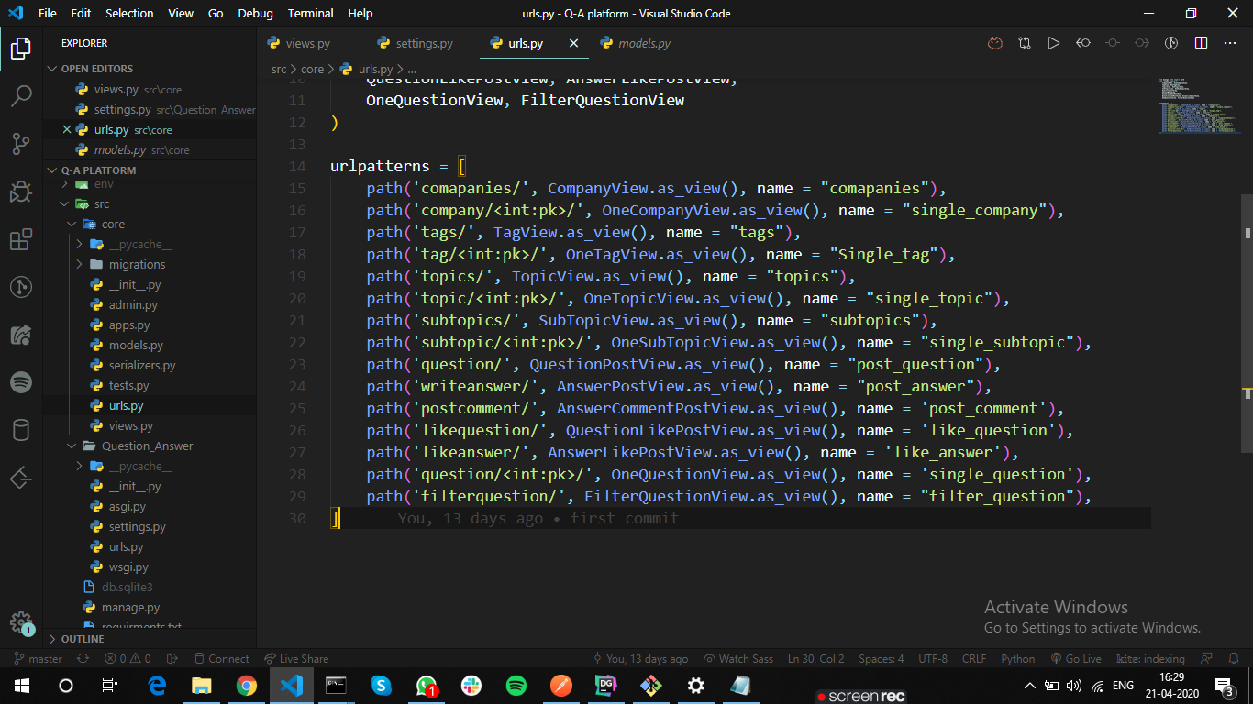

**i) /comapanies/ - get and post request for all company.**

**ii) /company/<int:pk>/ - CRUD operation for one company.**

**iii) /tags/ - get and post request for all tags.**

**iv) /tag/<int:pk>/ - CRUD operation for single tag.**

**v) /topics/ - get and post request for all topics.**

**vi) /topic/<int:pk>/ -CRUD operation for single topic.**

**vii) /subtopics/ - get and post requestv for all subtopic.**

**viii) /subtopic/<int:pk>/ - CRUD operation for one subtopic.**

**ix) /question/ - post request for Question.**

**x) /writeanswer/ - post request for Answer.**

**xi) /postcomment/ - post request for comment on specific answer.**

**xii) /likequestion/ - post request for Question like.**

**xiii) /likeanswer/ - post request forAnswer like.**

**xiv) /question/<int:pk>/ - get request for single question.**

**xv) /filterquestion/ - get request for Question on various parameter.**

**3) AWS Deployment**

**(IP Add: 3.136.86.246)**

Feel sorry to inform you that I partially succeed in the deployment process of API code on the AWS virtual machine. i.e (ec2 server instance)

**i) Screenshot for Server instance running in the browser.** **(IP- 3.136.86.246)**

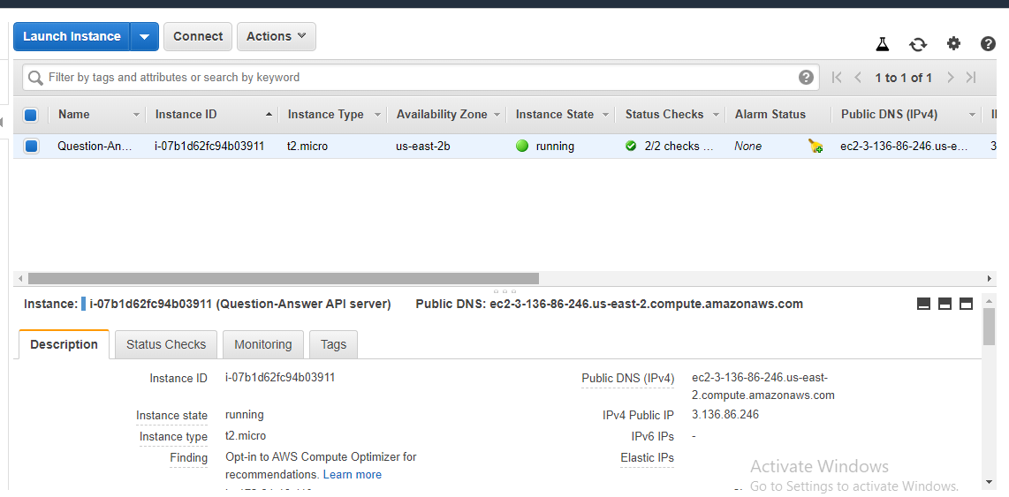

**ii) Files are uploaded on ec2 instance from my local m/c-**

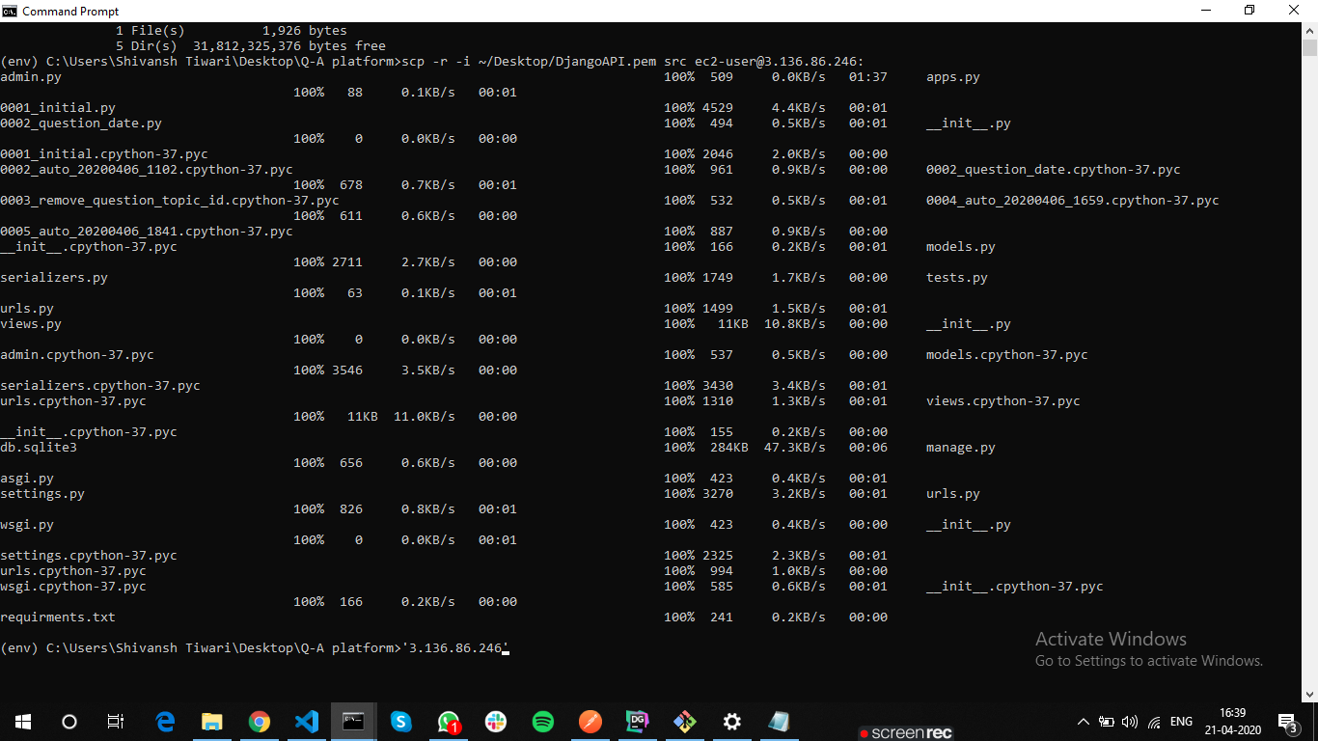

**iii) My Folder is App showing in the ec2 server instance.**

